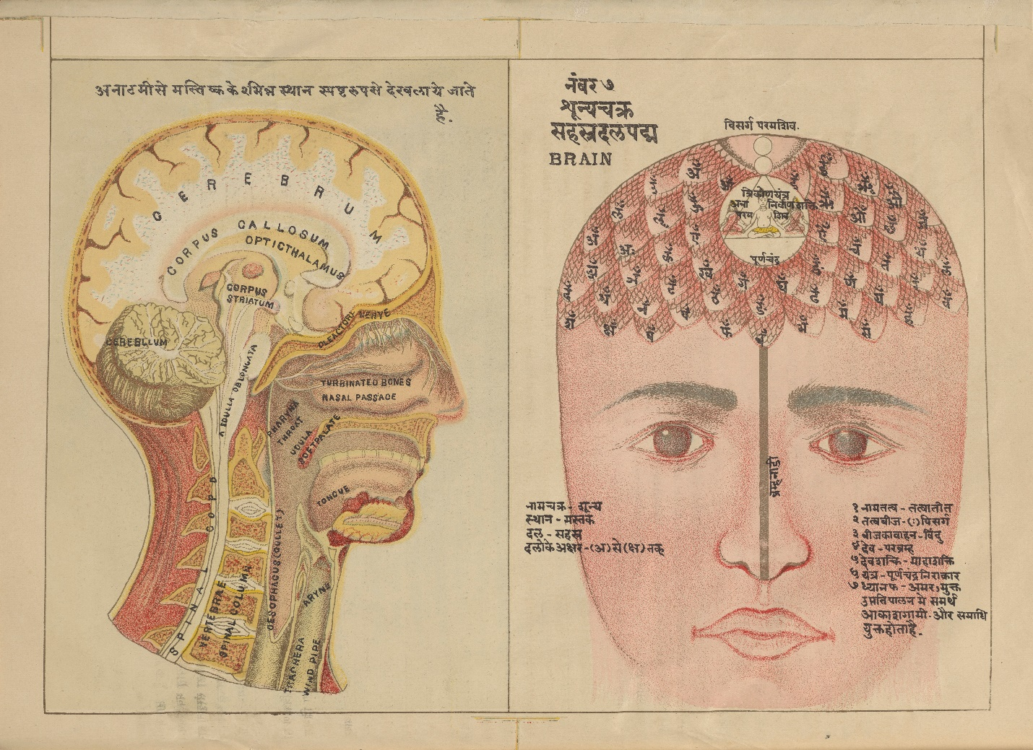

MS Sanskrit 391. Authored by Svami Hamsasvarupa, 1900s. Credit: [Wellcome Collection](https://wellcomecollection.org/works/vy8nz4km). [Attribution 4.0 International (CC BY 4.0)](https://creativecommons.org/licenses/by/4.0/)

**Ancient Indian view of the Nervous System**

Ancient Indian thought on the nervous system was similar in some sense to Ancient Greek ideas. Nerves (or Nadi) were viewed as hollow tubes through which prana vayu (similar to Ancient Greek pneuma) travelled carrying impulses to and from the brain. Similar vayus were associated with other functions such as speaking, digestion, and the movement of joints. The description of the five main vayus below is from the Sushruta Samhita. Ayurvedic texts talks of multiple channels that run throughout the body refered to as dhamani, sira, shrota, and nadi. While there have been modern attempts to translate these as arteries, veins and nerves, the modern terms may not be that accurate in reflecting ancient understanding of these systems. Dhamanis and siras are also sometimes considered to carry prana like nadis as well as blood (rakta). Therefore, it is better to understand these as channels or ducts through which various bodily effluvia such as blood, bile, vata (pneuma) and phlegm are transferred.

**The Prana Vayu**

The Vayu, that courses in (governs) the cavity of the mouth, is called the Prana, its function being to force down the food into the cavity of the stomach, and to assist the different vitalising principles of the body (such as the internal heat or fire etc.) in discharging their functions in life, and to contribute to the general sustenance of the body. A deranged condition of this particular kind of Vayu (Prana) is usually followed by hiccough, dyspnea and other kindred distempers. (Sushruta Samhita 2.1.13)

यो वायुर्वक्त्रसञ्चारी स प्राणो नाम देहधृक् | सोऽन्नं प्रवेशयत्यन्तः प्राणांश्चाप्यवलम्बते ||१३||

प्रायशः कुरुते दुष्टो हिक्काश्वासादिकान् गदान् |१४|

**The Udana Vayu**

The most important of the vital Vayus, which courses (sends its vibrations) upward, is called the Udana. It produces speech, song, etc. In its deranged state it brings on diseases which are specifically confined to regions lying above the clavicles. (Sushruta Samhita 2.1.14-15)

उदानो नाम यस्तूर्ध्वमुपैति पवनोत्तमः ||१४||

तेन भाषितगीतादिविशेषोऽभिप्रवर्तते | ऊर्ध्वजत्रुगतान् रोगान् करोति च विशेषतः ||१५||

**The Samana Vayu**

The Samana Vayu courses in (governs) the stomach (Amashaya) and in the region of intestines (Pakvashaya). Its functions consist in digesting the chyme brought down into the intestines in unison with the digestive ferment (Agni), and especially in disintegrating its essence from its refuse or excreted matter. A deranged or aggravated condition of the Samana Vayu causes dysentery, Gulma, and impaired digestion, etc. (Sushruta Samhita 2.1.16)

आमपक्वाशयचरः समानो वह्निसङ्गतः |

सोऽन्नं पचति तज्जांश्च विशेषान्विविनक्ति हि ||१६||

गुल्माग्निसादातीसारप्रभृतीन् कुरुते गदान् |१७|

**The Vyana Vayu**

The Vayu known as the Vyana courses (acts) through the whole organism, and its functions consist in sending the lymph chyle, etc. all through the body and in helping the out-flow of blood (Asrik) and perspiration. Five kinds of muscular movements are ascribed to the action of the Vyana Vayu, a deranged condition of which is generally attended with diseases which are not confined to any particular region, member, or organ of the body, but are found to affect the whole organism (such as, fever, etc). (Sushruta Samhita 2.1.17-18)

कृत्स्नदेहचरो व्यानो रससंवहनोद्यतः ||१७||

स्वेदासृक्स्रावणश्चापि पञ्चधा चेष्टयत्यपि |

क्रुद्धश्च कुरुते रोगान् प्रायशः सर्वदेहगान् ||१८||

**The Apana Vayu**

The Vayu known as the Apana acts in the lower region of the intestines (Pakvadhana). Its functions consist in bearing down the fetus and the feces and in evacuating the urine, semen and catamenial blood. An enraged condition of this Vayu tends to bring on serious diseases, which are peculiar to the urinary bladder and the distal portion of the large intestine (Guda). An aggravated condition of both the Vyana and Apana Vayus may produce Prameha and disorders of the seminal fluid, while a simultaneous excitement of the five vital Vayus leads to a sure and speedy termination of life. (Sushruta Samhita 2.1.19-20)

पक्वाधानालयोऽपानः काले कर्षति चाप्यधः |

समीरणः शकृन्मूत्रं शुक्रगर्भार्तवानि च ||१९||

क्रुद्धश्च कुरुते रोगान् घोरान् बस्तिगुदाश्रयान् |२०|

शुक्रदोषप्रमेहास्तु व्यानापानप्रकोपजाः ||२०||

युगपत् कुपिताश्चापि देहं भिन्द्युरसंशयम् |